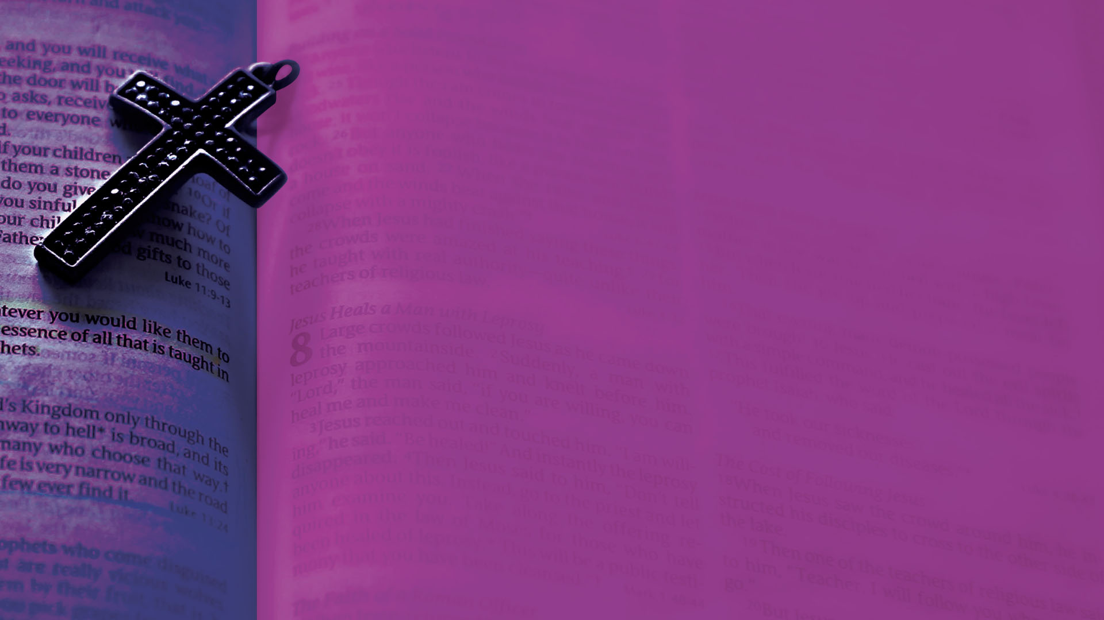

Happy 40th Anniversary
of Sacerdotal Ordination
to the Priesthood
Fr. Tony Yllana!
Congratulations on reaching this great
milestone in your priestly ministry!
May God continue to bless you and be
with you in all you do.

