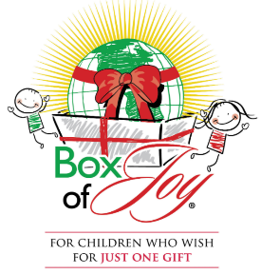

**Knights of Columbus to   
Bring Box of Joy Program   
to Our Parish!**

**Knights of Columbus Council 17335 is once again partnering with  
 Cross Catholic Outreach to bring its Box of Joy ministry project to our   
Church of the Good Shepard Parish!**

Members of the Knights will be distributing shoebox size cartons to parishioners following all Masses on the weekends starting September 14/15. Parishioners are invited to take home a box and fill it with items for boys and girls ranging from ages 2 to 15.  
 A $9 donation per Box of Joy is required to cover international shipping costs to the child.

**Boxes should be returned to the parish on or before November 10th** **and left in the in the commons area.**

Packing a Box of Joy is always a wonderful work of mercy for families and blessing a child with this gift is a special experience for everyone involved!

For more information, please contact Joe Campo at 757-357-2287 or the Parish Office at 757-365-0579. Thank you for your generosity!